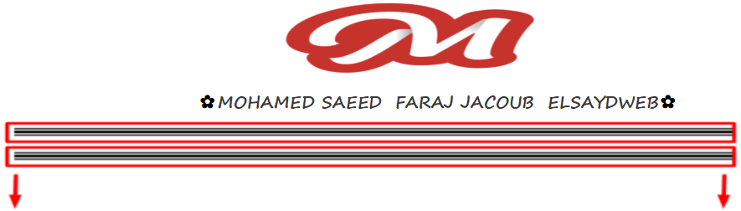

وده مثال عليه

<https://codepen.io/hatem-ghouthi/pen/ozbagP>

{{-- -------------------------------start news --}}  
<article class="content_news_bar">  
<div class="slideUp " id="news-bar">  
 <marquee direction="right" scrollamount="3" behavior="scroll" onmouseover="this.stop()" onmouseout="this.start()">  
 <a href="#" class="hvr-pop">الخبر الاولالخبر الاولالخبر الاولالخبر الاولالخبر الاولالخبر الاولالخبر الاولالخبر الاولالخبر الاولالخبر الاول100% Money Back Guarantee We will refund your money if you aren't satisfied in a week. 100% Money Back Guarantee. Laborum voluptas sed Numquam illum adipi  
 </a><a> -*- </a>  
  
 </marquee>  
</div>  
<style>  
  
 #news-bar {  
 width: 100%;  
 background: white;  
 box-shadow: 0 4px 10px black, 0 0 10px black inset;  
 border-radius: 15px;  
 font: 21px bold;  
 padding: 0;  
 padding-top: 2px;  
 padding-left: 20px;  
 padding-right: 20px;  
 }  
  
 #news-bar:hover {  
 transition: 0.37s;  
 }  
  
 #news-bar a {  
 padding:8px 2px;  
 color: black;  
 text-decoration: none;  
 }  
  
 #news-bar a:hover {  
 transition: 0.37s;  
 color: red;  
 }  
  
  
 /* Pop */  
  
 @-webkit-keyframes hvr-pop {  
 50% {  
 -webkit-transform: scale(1.2);  
 transform: scale(1.2);  
 }  
 }  
  
 @keyframes hvr-pop {  
 50% {  
 -webkit-transform: scale(1.2);  
 transform: scale(1.2);  
 }  
 }  
  
 .hvr-pop {  
 display: inline-block;  
 vertical-align: middle;  
 -webkit-transform: translateZ(0);  
 transform: translateZ(0);  
 box-shadow: 0 0 1px rgba(0, 0, 0, 0);  
 -webkit-backface-visibility: hidden;  
 backface-visibility: hidden;  
 -moz-osx-font-smoothing: grayscale;  
 }  
  
 .hvr-pop:hover,  
 .hvr-pop:focus,  
 .hvr-pop:active {  
 -webkit-animation-name: hvr-pop;  
 animation-name: hvr-pop;  
 -webkit-animation-duration: 0.3s;  
 animation-duration: 0.3s;  
 -webkit-animation-timing-function: linear;  
 animation-timing-function: linear;  
 -webkit-animation-iteration-count: 1;  
 animation-iteration-count: 1;  
 }  
  
  
 /* Float */  
  
 .hvr-float {  
 display: inline-block;  
 vertical-align: middle;  
 -webkit-transform: translateZ(0);  
 transform: translateZ(0);  
 box-shadow: 0 0 1px rgba(0, 0, 0, 0);  
 -webkit-backface-visibility: hidden;  
 backface-visibility: hidden;  
 -moz-osx-font-smoothing: grayscale;  
 -webkit-transition-duration: 0.3s;  
 transition-duration: 0.3s;  
 -webkit-transition-property: transform;  
 transition-property: transform;  
 -webkit-transition-timing-function: ease-out;  
 transition-timing-function: ease-out;  
 }  
  
 .hvr-float:hover,  
 .hvr-float:focus,  
 .hvr-float:active {  
 -webkit-transform: translateY(-8px);  
 transform: translateY(-8px);  
 }  
  
  
 /* slideUp */  
  
 .slideUp {  
 animation-name: slideUp;  
 -webkit-animation-name: slideUp;  
 animation-duration: 1s;  
 -webkit-animation-duration: 1s;  
 animation-timing-function: ease;  
 -webkit-animation-timing-function: ease;  
 visibility: visible **!important**;  
 }  
  
 @keyframes slideUp {  
 0% {  
 transform: translateY(100%);  
 }  
 50% {  
 transform: translateY(-8%);  
 }  
 65% {  
 transform: translateY(4%);  
 }  
 80% {  
 transform: translateY(-4%);  
 }  
 95% {  
 transform: translateY(2%)  
 }  
 100% {  
 transform: translateY(0%);  
 }  
 }  
  
 @-webkit-keyframes slideUp {  
 0% {  
 -webkit-transform: translateY(100%);  
 }  
 50% {  
 -webkit-transform: translateY(-8%);  
 }  
 65% {  
 -webkit-transform: translateY(4%);  
 }  
 80% {  
 -webkit-transform: translateY(-4%);  
 }  
 95% {  
 -webkit-transform: translateY(2%);  
 }  
 100% {  
 -webkit-transform: translateY(0%);  
 }  
 }  
</style>  
</article>  
{{-- -------------------------------End news --}}

